**Technical Documentation – Stage_Compile_Deploy_BATCH_Reports**

1. Workflow – Stages (from SVN), Compiles and Deploys BATCH Reports to an Environment.

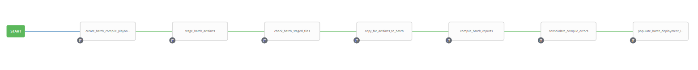

1. Survey – User Supplied Variables

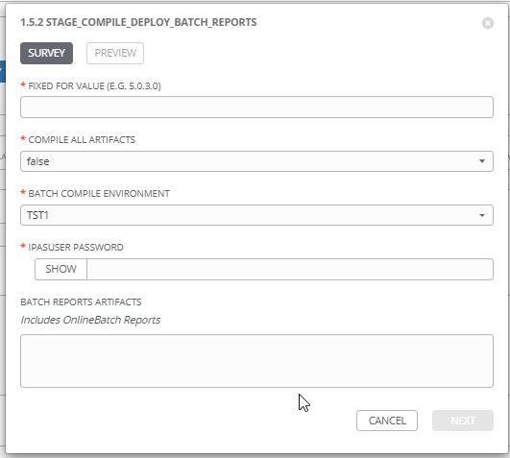

|  |  |  |  |
| --- | --- | --- | --- |
| **Survey Extra Variables** | **Prompt** | **Type** | **Description and Usage** |
| FFV | Fixed For Value | Text | The fixed for value for the deployment – must be for the format ###.###.###.### (i.e. 58.0.12.0). Numbers only with a maximum of 3 digits and there must be 4 sets separated with a ‘.’. Used to create staging and deployments directories. Used by all job templates in the workflow |
| CompileAll | Compile All Artifacts | Multiple Choice Single Pick | True or false – default of false will only compile forms and reports that exist in the stage directory. If a pll is part of the deployment, CompileAll **MUST** be set to true, logic being all FAR Artifacts must be recompiled if a new pll is deployed (re: Geoff G.). |
| ENV | Batch Compile Environment | Multiple Choice Single Pick | The Environment to Compile and Deploy the FAR Artifact into: DEVL, DEV3, RDEV, TST1, TST2, TST3, MUAT, IPASP. Only a single environment can be compiled in and deployed to per workflow execution |
| SchemaPassword | IPASUSER Password | Password | The password for the IPASUSER Schema in the Destination Environment. |
| BatchArtifacts | Batch Reports Artifacts  Includes OnlineBatch Reports | Text Area 20,000 characters | The SVN URL for each FAR Artifact to be compiled and deployed. Each URL has to be on a separated line.  Note this variable is optional and if left blank the FAR Artifact(s) would have to have been staged by a previous execution. If the stage directory does not contain any artifacts the workflow will fail. |

1. Jobs Used by the workflow - http://owl.penc.local:18080/svn/deploy_automation/trunk/Ansible_PlayBooks/FAR

| **Job Template** | **Ansible Playbook** | **Credentials / host** | **Project** | **Description and Usage** |
| --- | --- | --- | --- | --- |
| create_batch_compile_playbook_vars | create_batch_compile_playbook_vars.yml | None – runs on localhost as awx linux user | FAR Deployments | Batch_Compile_Directory: 'D:\Reports\defs\tst3'  DeploymentLogDir: /codemove_common/dp_automation/deployments/069.028/069.028.004.000/FAR  Oracle_DB: TST3  StageDir: /codemove_common/dp_automation/stage/069.028/069.028.004.000/FAR  batch_far_server: cronreptest1  rwconverter: 'D:\opt\oracle\domains\WLS_JCSTEST\reports\bin\rwconverter.bat'  stage_server: diagoras1bcp  tower_hostname: pdeploy1bcp.penc.local |
| stage_batch_artifacts | stage_batch_artifacts.yml | Codemove for {{stage_server}} – diagoras1bcp  pendeploy_svn – used to extract artifacts using the svn urls supplied. | FAR Deployments | When the BatchArtifacts is populated with SVN URLs export the artificats from SVN and place them in the Batch Staging directory {{StageDir}}/artifacts/Batch.  Creates a Staging file report in the {{DeploymentLogDir}} |
| check_batch_staged_files | check_batch_staged_files.yml | Codemove for {{stage_server}} – diagoras1bcp | FAR Deployments | Checks the {{StageDir}}/artifacts/Batch to make sure at least one of *.rdf or *.pll file(s) exists. If there are no artifacts in the directory or the directory does not exist produce an error. |
| copy_far_artifacts_to_batch | copy_far_artifacts_to_batch.yml | Penc\ora_cronreptest for {{batch_far_server}} – cronreptest1 | FAR Deployments | Copies all FAR Artificats staged into the {{Batch_Compile_Directory}}. If any *.olb or *.tif files exist copy them to the {{Runtime_Directory}} since they do NOT get processed by any of the compile playbooks. |
| compile_batch_reports | compile_batch_reports.yml  Calls  compile_single_batch_form_pll.yml  and  compile_single_batch_report.yml | Penc\ora_cronreptest for {{batch_far_server}} – cronreptest1 | FAR Deployments | compile_batch_reports, compiles FORM pll and rdf files.  When CompileAll is true the compile_single_batch_form_pll.yml is executed which will compile WEBUTIL.pll, D2KWUTIL.pll, CONST.pll, SYSLIB.pll, SYSMSG.pll, PFXCONST.pll, AUDIT.pll, POS.pll, NOTC.pll, RPT_ROLE.pll, IPSRPT.pll. It is assumed CompileAll will be set to true if ANY new pll is deployed. By default it is set to ‘false’.  If any of the pll compiles produces an error {{Batch_Form_PLL_Errors}} is populated.  {{Batch_Form_PLL_Deployment_Feedback}} is populated for each plx created.  When CompileAll is true compile_single_batch_report.yml is executed against ALL rdf files in the {{Batch_Compile_Directory}}. If CompileAll is false, compile_single_report.yml is executed only against rdf files in the {{StageDir}}/artifacts/Batch.  If any of the rdf compiles produces an error {{Batch_Report_Errors}} is populated.  {{Batch_Report_Deployment_Feedback}} is populated for each rep created. |
| consolidate_compile_errors | consolidate_compile_errors.yml | None – runs on localhost as awx linux user | FAR Deployments | Consolidates all ERRORS generated – Note that this jobs is used by all Forms and Reports workflows (Online, Batch, web, etc.). |
| populate_batch_deployment_logs | populate_batch_deployment_logs.yml | Codemove for {{stage_server}} – diagoras1bcp | FAR Deployments | Populates the deployment log {{DeploymentLogDir}}/{{ENV}}_Batch_Log.html with the pll, mmb, fmb and rdf feedback generated during the compiles.  Populates the error log {{DeploymentLogDir}}/{{ENV}}_Batch_Compile_Errors.html with any ERRORS generated during the compiles.  If Compile errors exist emails the {{DeploymentLogDir}}/{{ENV}}_Batch_Compile_Errors.html file to:  - PENC_ITS_ADM_Release_Management@Victoria1.gov.bc.ca  - PENC_ITS_TSS_Midtier@Victoria1.gov.bc.ca |